**Calculator Free**

**General Continuous Random Variables and the Normal Distribution**

Time: 45 minutes

Total Marks: 45

Your Score: / 45



**Question One: [3, 5 = 8 marks] CF**

Consider the probability density function drawn below:

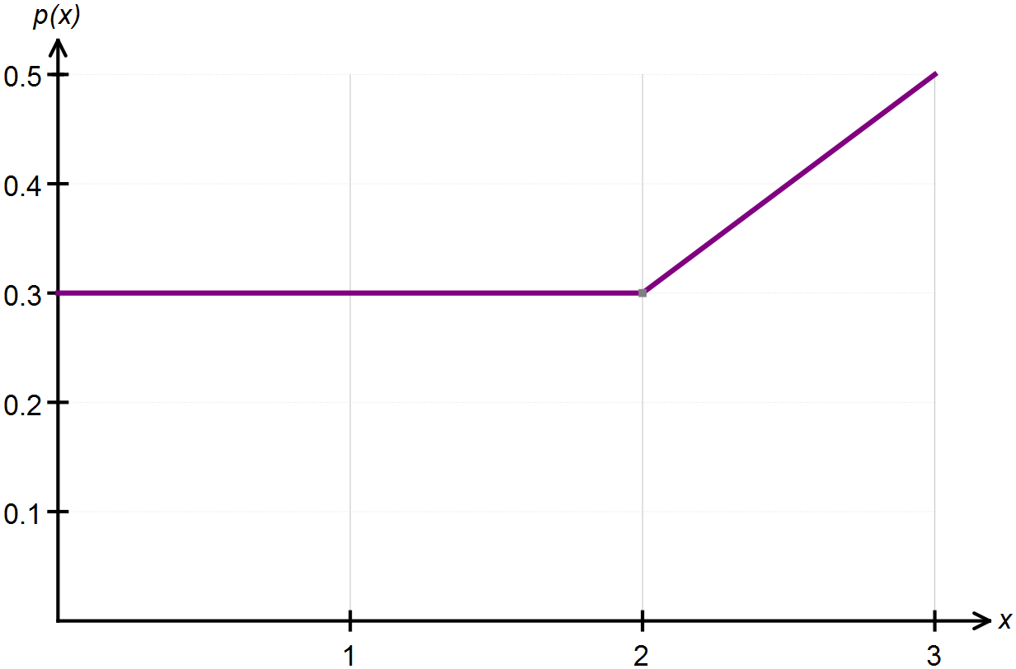

(a) Confirm, with appropriate calculations, that this above graph represents a probability density function.

(b) State the piecewise function that defines this continuous random variable.

**Question Two: [4, 4, 4 = 12 marks] CF**

Determine the value(s) of *k* which make each of the following functions a probability density

function.

(a) 

(b) 

(c) 

**Question Three: [1, 2, 2, 2, 2, 2 =11 marks] CF**

Columbus is playing with a broken compass and he spins the compass needle around.

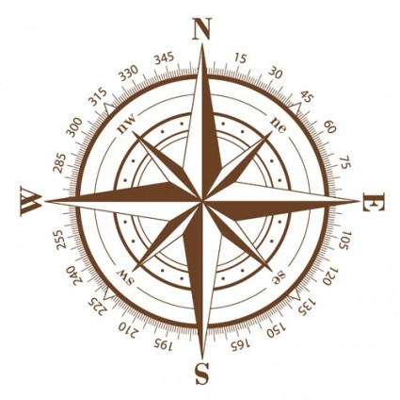

(a) Determine the probability the compass needle lands

between the North and East.

(b) Determine the probability the compass needle lands

between the South and NorthWest.

(c) Use your answers to parts (a) and (b) to sketch the

uniform probability density function that models

each spin of the compass needle. Let X be the true bearing.

(d) Hence define the probability density function,  .

(e) The expected value of a uniform distribution is calculated by  , where *a* and *b* are the endpoints over which the distribution is defined. Calculate  .

(f) The variance of a uniform distribution is calculated by  . Calculate  .

**Question Four: [4 marks] CF**

On a recent test, Tom scored 70% and his standard score was 1. Jerry sat the same test and his standard score was -0.5 when he scored 55%.

Calculate the mean and standard deviation for these test results.

**Question Five: [2, 2, 2, 2, 2 = 10 marks] CF**

The heights of fairy penguins in a particular geographic location are normally distributed with a mean height of 32 cm and a standard deviation of 1.5 cm.

Use the 68%, 95% and 99.7% rule to calculate each of the following.

(a) Determine the probability that a randomly selected fairy penguin is taller than 30.5 cm.

(b) Determine the probability of a randomly selected fairy penguin being shorter than 30.5 cm if it is known that they are in the 0.5 quantile.

(c) In a sample of 2000 penguins, how many would you expect to be taller than 35cm?

(d) What is the maximum height of the shortest 2.5% of penguins in this location?

(e) In a different geographic location the mean height of the fairy penguins found there is 33 cm. If 97.5% of the penguins are shorter than 35cm, and their heights are also normally distributed, what is the standard deviation for this population?

**SOLUTIONS**

**Calculator Free**

**General Continuous Random Variables and the Normal Distribution**

Time: 45 minutes

Total Marks: 45

Your Score: / 45



**Question One: [3, 5 = 8 marks] CF**

Consider the probability density function drawn below:



(a) Confirm, with appropriate calculations, that this above graph represents a probability density function.





(b) State the piecewise function that defines this continuous random variable.







**Question Two: [4, 4, 4 = 12 marks] CF**

Determine the value(s) of *k* which make each of the following functions a probability density

function.

(a) 

 

(b) 

 

(c) 

 

**Question Three: [1, 2, 2, 2, 2, 2 =11 marks] CF**

Columbus is playing with a broken compass and he spins the compass needle around.



(a) Determine the probability the compass needle lands

between the North and East.





(b) Determine the probability the compass needle lands

between the South and NorthWest.





(c) Use your answers to parts (a) and (b) to sketch the

uniform probability density function that models

each spin of the compass needle. Let X be the true bearing.

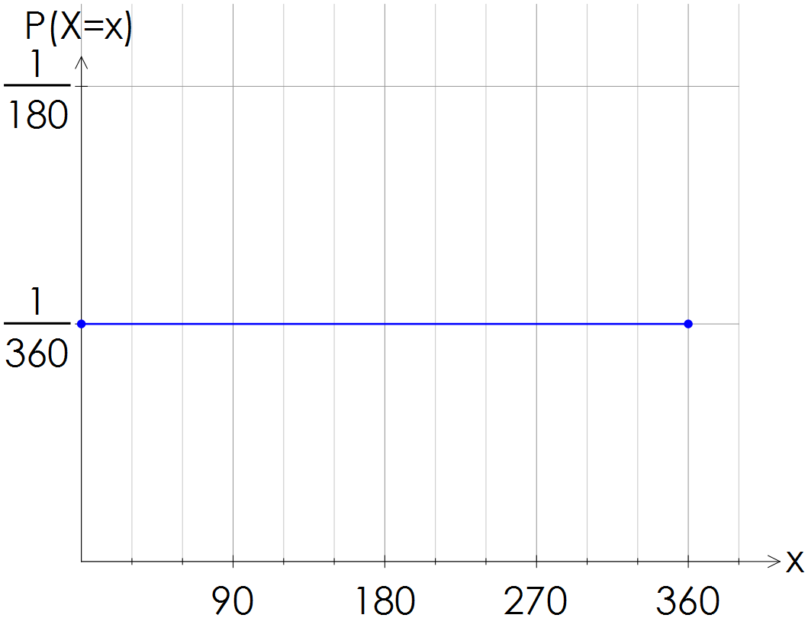





(d) Hence define the probability density function,  .



(e) The expected value of a uniform distribution is calculated by  , where *a* and *b* are the endpoints over which the distribution is defined. Calculate  .

 



(f) The variance of a uniform distribution is calculated by  . Calculate  .





**Question Four: [4 marks] CF**

On a recent test, Tom scored 70% and his standard score was 1. Jerry sat the same test and his standard score was -0.5 when he scored 55%.

Calculate the mean and standard deviation for these test results.



**Question Five: [2, 2, 2, 2, 2 = 10 marks] CF**

The heights of fairy penguins in a particular geographic location are normally distributed with a mean height of 32 cm and a standard deviation of 1.5 cm.

Use the 68%, 95% and 99.7% rule to calculate each of the following.

(a) Determine the probability that a randomly selected fairy penguin is taller than 30.5 cm.

 

(b) Determine the probability of a randomly selected fairy penguin being shorter than 30.5 cm if it is known that they are in the 0.5 quantile.

 



(c) In a sample of 2000 penguins, how many would you expect to be taller than 35cm?



 

(d) What is the maximum height of the shortest 2.5% of penguins in this location?



 

(e) In a different geographic location the mean height of the fairy penguins found there is 33 cm. If 97.5% of the penguins are shorter than 35cm, and their heights are also normally distributed, what is the standard deviation for this population?

